https://www.figma.com/design/bJLCEutpAgjjuHR2MLC96y/ADA-UI
1) Verify OTP
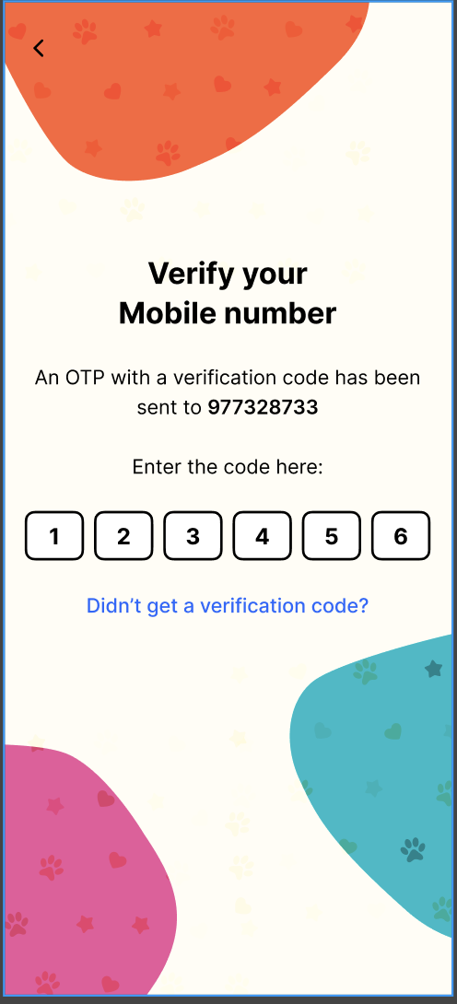
API - register.uat.advikapetworld.com/v1/login/VerifyOTP
Parameter : {
"UserId": "8097479830",
"Deviceid":"local",
"Otp":"260020",
"type":"login",
"sessionId":"localsession",
"latitude":"488",
"longitude":"588"
}
Send User current latitude longitude with allow permission first
After verifying replace login screen and navigate it to role selection screen
Half api integration is already done just send lat & long.
Integrate Refresh Token in authApi file
API : register.uat.advikapetworld.com/v1/login/RefreshToken
Parameter:
{
"token": "8fd027cd-d376-410e-899c-1b3d62133f8c",
"Deviceid": "local",
"sessionId": "localsession1",// hard coded value, we have send firebase fcm
"latitude": "4881",
"longitude": "5881"
}
Send User current latitude longitude
Session Detail
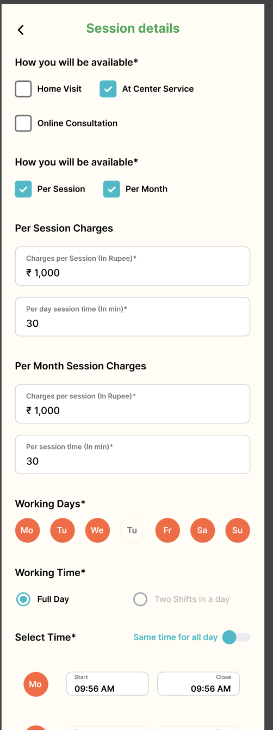
In this screen two apis are there
Api register.uat.advikapetworld.com/v1/register/provider/addsession
Parameter:
{
"userid": "8097479830",
"availableat": "As service center",
"ispersession": 1,
"ispermonth": 1,
"isfullday": 1,
"sessiontime": "30",
"monthtime": "40"
}
Apr: register.uat.advikapetworld.com/v1/register/provider/addsessiondetails
{
"userid": "pramodjadhav596@gmail.com",
"sessionDetails": [
{
"day": "Mon",
"type": "1st half",
"start": "8:30 AM",
"close": "10:30 AM"
},
{
"day": "Mon",
"type": "2nd half",
"start": "02:30 PM",
"close": "3:30 PM"
}
]
}
Getprofile
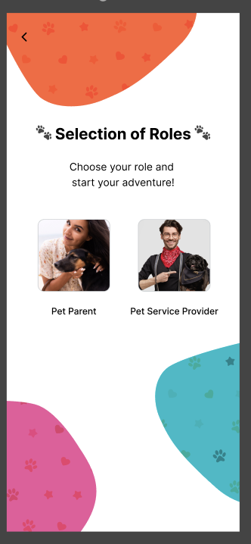
API: register.uat.advikapetworld.com/v1/register/getprofile
Parameter
{
"userid": "7977276381"
}
Call This api in the role selection screen and on the home screen
It gives you data whether you have done the register or not
If not registered then in the myprofile-> show all the register tabs pending.
And it will not allow to do payment also there also it will show pending check below screenshot
Call me once for the flow …..